Name: Goran Sekulić
E-mail: sgoran2000@gmail.com
Institution: University of Montenegro, Faculty of Civil Engineering
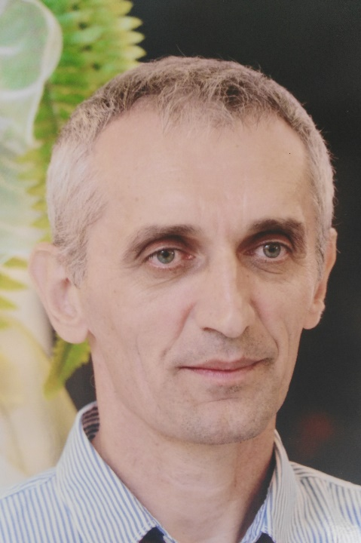 | Goran Sekulić, PhD, full professor at the University of Montenegrs, was born in 1964 in Belgrade, the Republic of Serbia. He obtained his academic degrees at the Faculty od Civil Engineering in Belgrade (MSc in 1994, and PhD in 2004). During his academic career, he was teaching over fifteen different academic courses on BSc, MSc and PhD degree. He wrote more than 100 scientific papers for journals and conferences, mainly in his areas of interest: water supply systems, wastewater and stormwater engineering, modeling of various processes in hydrotechnical projects, water protection, protection from water, physical and town planning (water engineering components), reconstruction and renewal of communal infrastructure, the legislative aspects of the use and protection of water resources. He participated in more different domestic and international projects. He is also a member of several professional organizations and a reviewer in national and international journals
References (max. 5 relevant references)
1. Milan Radulović, Goran Sekulić, Momčilo Blagojević, Jelena Krstajić, Entela Vako, An assessment ofterritory participation in transboundary karst aquifer recharge: A case study from the Skadar Lake catchment area BOOK : Karst without Boundaries,, 2016, by CRC Press Reference-360 Pages , CAT# K2967 Series: IAH - Selected Papers on Hydrogeology, ISBN 9781138029682
2. Sreten Tomovic, Goran Sekulić, Application of multi-criteria optimisation in marina planning onthe Montengrin coast, Polish Maritime Research, pp. 86-90, 2/2014, ISSN 1233-2585, DOI: 10.2478/pomr-2014-0024
3. Sava Petković, Goran Sekulić, Erosion and sedimentation processes in the Bojana River Delta at the Adriatic Sea, Journal of Coastal Conservation, https://doi.org/10.1007/s11852-018-0634-9, 2018.
4.Ivana Ćipranić, Goran Sekulić ,The analysis of the influence of soil on leakage in water supply systems, The journal Tehnički vjesnik/Technical Gazette, Vol. 22/No. 5, 2015. (Print: ISSN 1330-3651, Online: ISSN 1848-6339)
5. Goran Sekulić , Marija Ivković, Ivana Ćipranić, Modeling of hydrological processes in thecatchment area of Lake Skadar, The journal Tehnički vjesnik/Technical Gazette, ISSN 1330-3651 (Print), ISSN 1848-6339 (Online) https://doi.org/10.17559/TV-20151120230958)

This project has been funded with support from the European Commission. This publication reflects the views only of the author, and the Commission cannot be held responsible for any use which may be made of the information contained therein.

